COS30018 - Project Report

Project: Traffic Flow Prediction System

Authors:

Project Title: Traffic Flow Prediction System
  Name: Hoàng Minh Đức  Student ID: 105541452  Contributions: Main programmer, model training / testing, GUI building, report writing, presentation and video recording |   Name: Nguyễn Hoàng Tuấn Kiệt  Student ID: 104773652  Contributions: None.

Table of Contents
Table of Contents 2
Introduction 2
Dataset and Data Preparation 2
Models 3
Model Training 4
Training Results 7
GUI 7
Future Work 8
References 10

Introduction
In modern societies, “road traffic holds significant importance in both the economy and daily life” (Liu & Shin, 2025). Accurate traffic flow prediction “lays a vital role in mitigating congestion, optimizing traffic strategies, and reducing environmental impacts” (Carianni & Gemma, 2025).

Due to the importance of traffic flow forecasting, Liu & Shin(2025) have investigated various traffic flow prediction methods. In this project, we apply LSTM and GRU deep learning models to predict traffic flow.

The project uses Keras as the main training and testing library, Pandas (with xlrd to read Excel data) and Numpy for data processing.

Dataset and Data Preparation

Our project uses the Traffic Flow data from Boroondara in October 2006. The dataset’s files are provided on the unit Canvas.

The main dataset file used is Scats Data October 2006.xls. It contains three sheets, the first contains some notes, the second contains actual flow data, and the third contains a summary of the data. The data we will use comes from the second sheet.

First, we need to clean the data. Due to its format, it requires several special formatting steps. Then, we remove all locations with less than 7 days of recorded data (too little data for models) and locations with more than 31 days of recorded data (too much data for models). After initial cleaning and filtering, we load and process the second sheet. Due to formatting issues, the second sheet after cleaning and processing is saved to the Scats Data.csv file for convenience. The flow data is in intervals of 15-minutes spanning from the first day of October 2006 to the last, but some days have removed values. Thus, I filled zeros in the missing spots.

The data contains several columns, such as SCATS Number, road name, and flow data, geographical attributes (Latitude, Longitude), as well as various internal information. Each SCATS number has several sensors, and they are differentiated by their value in the HF Vicroads Internal Column. Therefore, to classify the sensors, I decided to create a new Identifier column that combines SCATS Number and HF Vicroads Internal , which creates 137 sensors. I dropped every other column except for actual flow data, due to our purely time-series approach.

After processing, the processed dataset is saved to a file called Scats Data.csv.

To prepare data for the training and testing, we make time-series windows of 1-week time length (or 672 values per window). This ensures that the data is able to predict far enough into the future. We also split the windows into first 70% of windows for training, middle 15% of windows for validation and the last 15% for testing.

Models

In this assignment, we will use LSTM and GRU, which are two different deep-learning models, to predict the flow. Both models are multiple-location, meaning that they train, evaluate and test on the data of all locations simultaneously instead of the approach used in the original GitHub repository (models for one single location). If we were to train single-location prediction models on all 137 locations individually, it would make the models unable to learn the influence between locations that are geographically close. Our choice of LSTM and GRU is based on the models used in the original code, however we adapted them for multiple-location training, testing and prediction.

LSTM (Long-Short Term Memory) is an enhanced type of Recurrent Neural Network (RNN) aimed at mitigating the problem of exploding or vanishing gradients experienced by traditional RNNs. LSTMs also have been widely used as a method for traffic flow prediction (Liu & Shin, 2025)

GRU (Gated Recurrent Units), defined by Cho et al. (2014), is a gating mechanism for RNNs. GRUs are similar to LSTMs with a gating mechanism, however they lack the memory cell mechanism. Also compared to LSTM, GRUs have fewer parameters, which results in higher computational efficiency. (Liu & Shin, 2025).

A comparison by Fu et al. (2016) of LSTM and GRU for the PeMS dataset showcased that GRU showed a slight improvement (5%) compared to LSTM. In this project, we compared their performances on the processed Boroondara dataset.

Model Training

The structure of the LSTM and GRU models used are as follows:
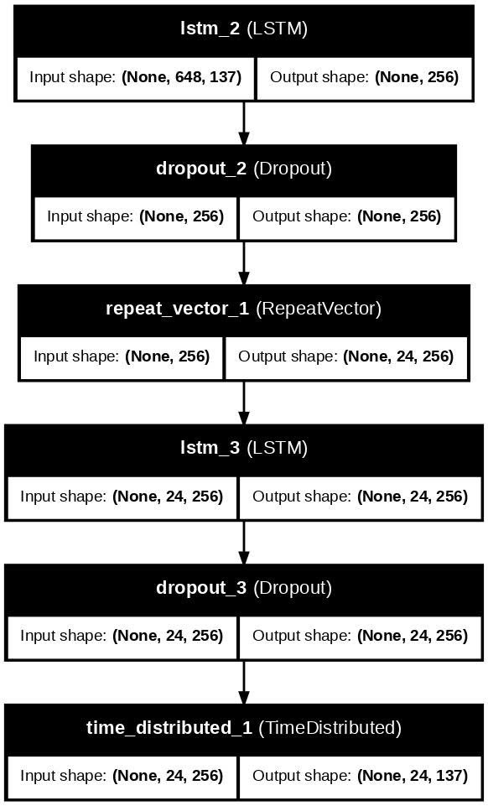
Figure 1: LSTM Model Structure

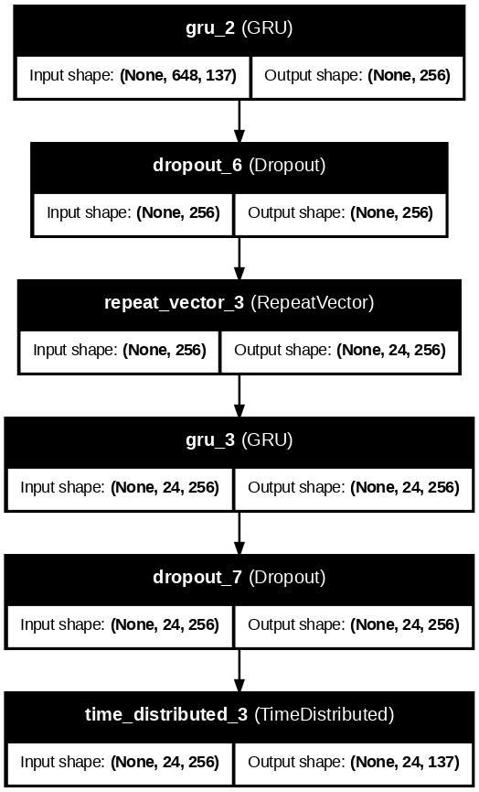
Figure 2: GRU Model Structure

Both models use AdamW as the optimizer. For callbacks, both used ReduceLROnPlateau to reduce the learning rate, which avoids being stagnant; and EarlyStopping to stop training when the monitored metric (in this case, MSE) stops improving to reduce training time.

Training Results

After training, we obtain the following error values on normalized test data:

Model Type | MAE | MSE | RMSE | R2
LSTM | 0.394569 | 0.504611 | 0.710360 | 0.448813
GRU | 0.356201 | 0.406004 | 0.637184 | 0.556522

After denormalizing, the error values are as follows:

Model Type | MAE | MSE | RMSE | R2
LSTM | 34.609779 | 3882.469204 | 62.309463 | 0.448813
GRU | 31.244328 | 3123.785721 | 55.890838 | 0.556522

In practice, these values may be different due to the randomization introduced in data processing by models.

This comparison shows that LSTM has higher error scores and a lower R2 score than GRU, while also comes with a higher number of parameters. (963,977 v.s. 733,321). Thus the GRU model performs better by a small margin, and is used in the GUI by default for prediction.

The prediction is done recursively, later predictions are stacked on previous predictions. This can cause issues when predicting data farther into the future.

GUI

The GUI is built using Gradio, a popular interface framework for AI/ML projects. The input receives the SCATS value and two timestamps, and outputs a predicted value for traffic flow in sensors of locations with that SCATS value. Note that since a single SCAT value can have multiple sensors, the output of those sensors are averaged for a prediction. The GRU model is chosen by default for prediction due to it’s higher performance

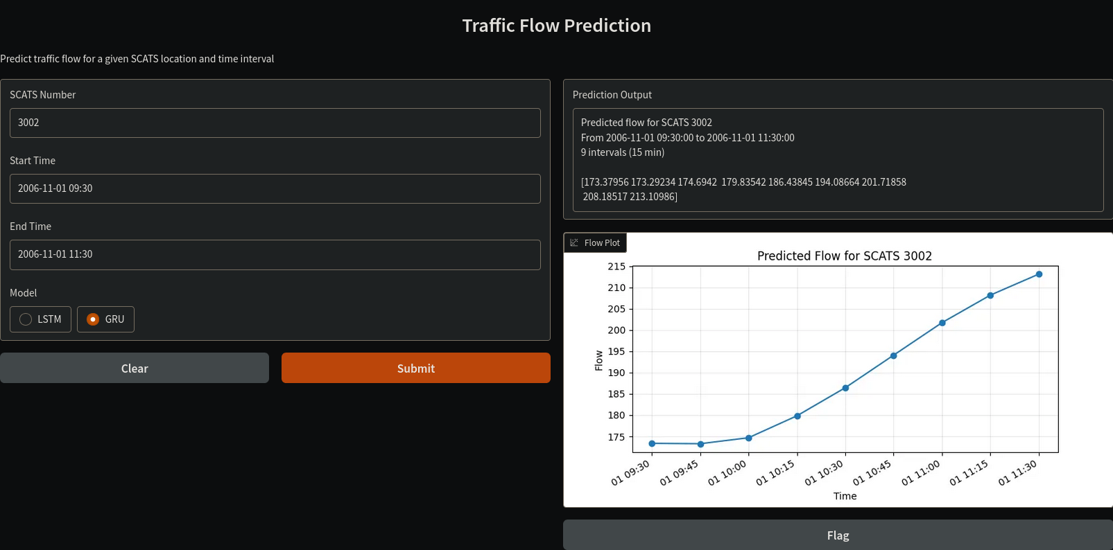

Figure 3: Simple GUI for prediction

The user would enter a SCATS number, as well as two timestamps in the specified format (YYYY-MM-DD HH:MM) for prediction, then picked a model. Afterwards, the user can click “Submit” to load the data into the predictions.

Note: On the Prediction output in certain cases, the “Prediction Output” block doesn’t have enough height, and you can scroll down to obtain the predictions. This is a flaw in Gradio and not the code.

Note that due to the models’ large sizes, prediction may take a long time. An alternative approach that reduces prediction time for individual SCATS locations / identifiers is to train individual models for each identifier, then predict on them.

Critical analysis of the implementation

Several issues and the implementation include high-error models, lacking-feature GUIs, etc. Furthermore, models’ architecture may not allow backwards prediction.

Future Work

In the future, we might expand on this project with newer datasets, different model types and optimizers. We also note the high denormalized error values for both models and we hope to be able to reduce via various hyper-parameter tuning methods. Furthermore, the method of using multiple-location models are expensive for both training and inference, and we will explore other methods (e.g per-identifier single-location models).

References

Liu, R., & Shin, S. (2025). A review of Traffic flow Prediction Methods in Intelligent Transportation System Construction. Applied Sciences, 15(7), 3866. https://doi.org/10.3390/app15073866

Carianni, A., & Gemma, A. (2025). Overview of traffic flow forecasting techniques. IEEE Open Journal of Intelligent Transportation Systems, 6, 848–882. https://doi.org/10.1109/ojits.2025.3580802

Cho, K., Bart, V. M., Gulcehre, C., Bahdanau, D., Bougares, F., Schwenk, H., & Bengio, Y. (2014, June 3). Learning Phrase Representations using RNN Encoder-Decoder for Statistical Machine Translation. arXiv.org. https://arxiv.org/abs/1406.1078

Zhao, Z., Chen, W., Wu, X., Chen, P. C. Y., & Liu, J. (2017). LSTM network: a deep learning approach for short‐term traffic forecast. IET Intelligent Transport Systems, 11(2), 68–75. https://doi.org/10.1049/iet-its.2016.0208

